Example B grade: Device: 353031114681875

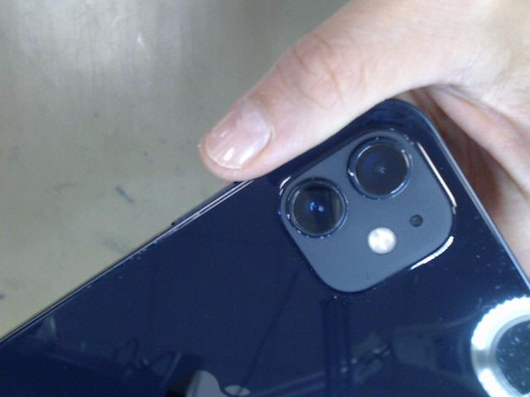

Example C grade: Device: 353037114740157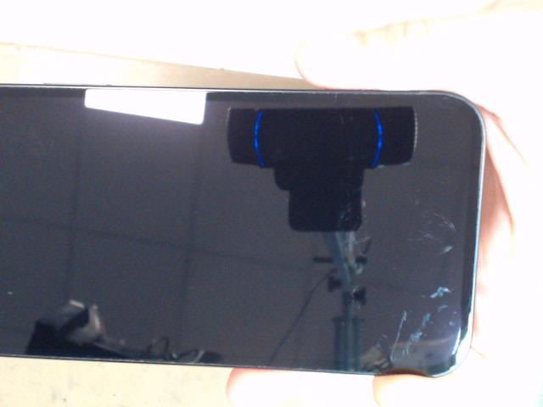

Example F grade: Device: 353032118653944

